**DECLARATION**

I hereby declare that the Internship report entitled “**Website and Webpage Development for Vaave**” submitted to the BMS Institute of Technology & Management, Yelahanka, Bengaluru has been carried out by me and submitted in partial fulfilment of the course requirements for the award of degree in Bachelor of Engineering in Computer Science and Engineering of Visvesvaraya Technological University, Belagavi, during the academic year 2021 - 2022. The matter embodied in this report has not been submitted to any other university or institution for the award of any other degree.

***Signature of the Student***

### A Nitya Dyuthi

### 1BY18CS001

# ACKNOWLEDGEMENT

I am happy to present this Internship Seminar after completing it successfully. This Internship would not have been possible without the guidance, assistance and suggestions of many individuals. I would like to express my deep sense of gratitude and indebtedness to each and everyone who has helped me to make this Internship a success.

I heartily thank our **Principal, Dr Mohan Babu G. N, BMS Institute of Technology & Management** for his constant encouragement and inspiration in taking up this Internship work.

I heartily thank our **Head of Department Dr Thippeswamy G, Dept. of Computer Science and Engineering, BMS Institute of Technology& Management** for his constant encouragement and inspiration in taking up this Internship work.

I heartily thank my external guide, **Mr Paresh Masade, Vaave,** for his constant support and guidance throughout the course of the Internship work.

I heartily thank our Internal guide **Mrs Durga Bhavani A Asst. Professor, Dept. of Computer science and Engineering,** for her constant follow-up and advice throughout the course of the Internship work.

Special thanks to all the staff members of the Computer Science Department for their help and kind co-operation.

Lastly, I thank my parents and friends for their encouragement and support given to me in order to finish this precious work.

By,

### A Nitya Dyuthi

**I**

**INTERNSHIP CERTIFICATE**

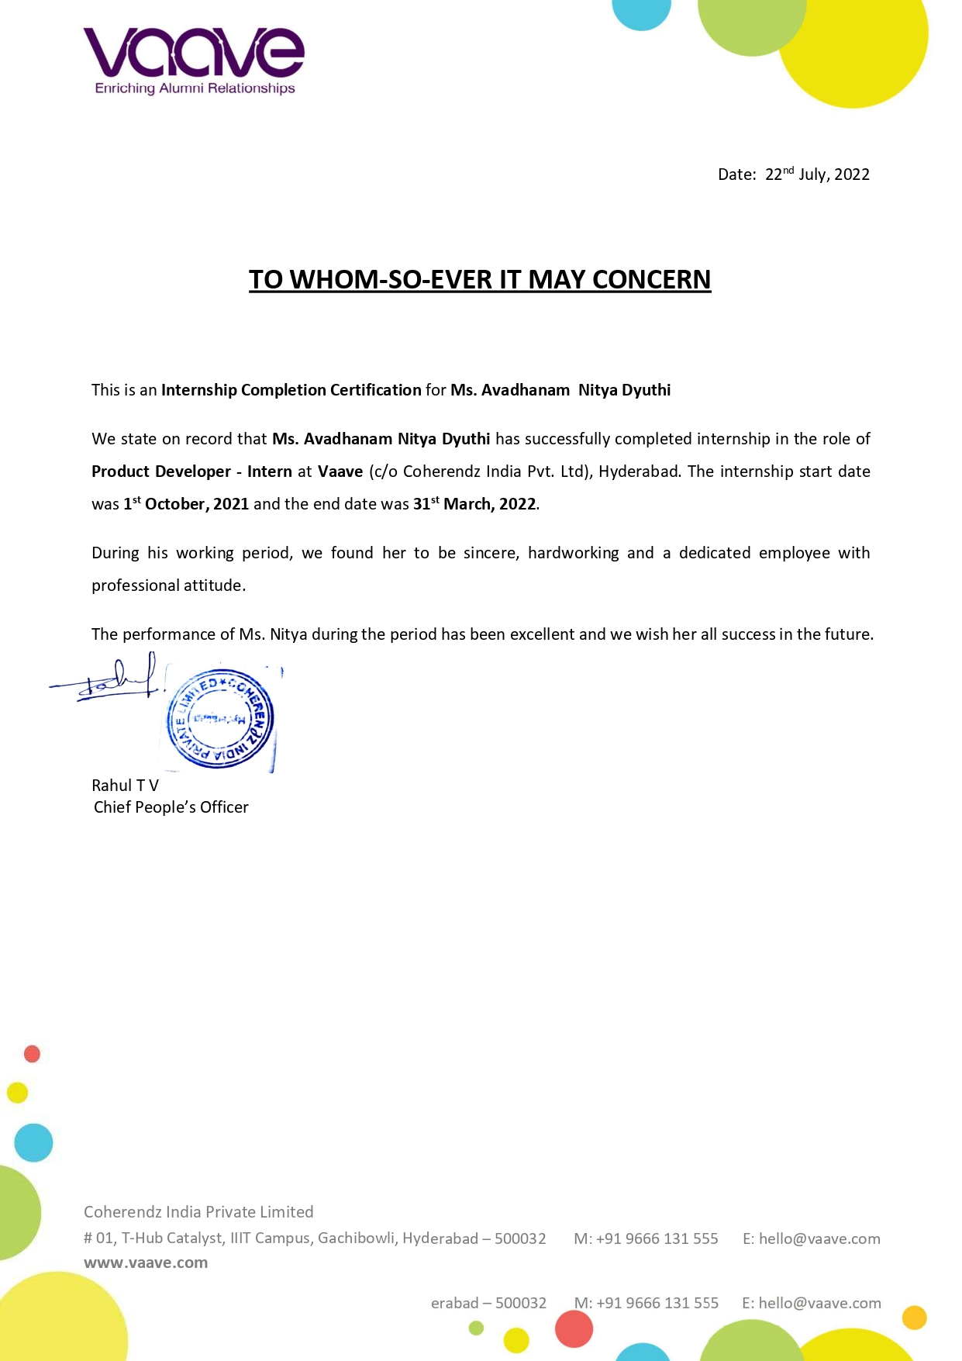

**II**

**ABSTRACT**

Vaave is a company based in Hyderabad, India, that helps institutions manage alumni relationships. They serve not just educational, but also corporate institutions in establishing connections with their alumni.

At vaave, I interned as a full-stack web developer for their web platform. I worked with the sales team, the product design team and the development team to create multiple components for their primary as well as subsidiary applications. As part of the internship, I was tasked with developing website interfaces and components through a rigorous development cycle. The internship was conducted remotely through work from home.

The 6-month internship helped me hone my knowledge in technology, development and soft skills.

**III**

**TABLE OF CONTENTS**

**1 ACKNOWLEDGEMENT I**

**2 INTERNSHIP CERTIFICATE II**

**3 ABSTRACT III**

**4 TABLE OF CONTENTS IV**

|  |  |
| --- | --- |
| 1. **Company Profile** | **1** |
| 1.1 Introduction | 1 |
| 1.2 Services | 2 |
| 1.3 Company Products | 5 |
| 1.4 The Clients | 5 |
| 1. **About The Department** | **7** |
| 2.1 The Development Department | 7 |
| 2.2 Team Objective | 7 |
| 2.3 Team Operation | 8 |
| 2.4 Web Application Development Process | 9 |

| 1. **INTERNSHIP DOMAIN** | **10** |
| --- | --- |
| 3.1 Introduction | 10 |
| 3.2 Tools and Technologies Used | 11 |
| 1. **TASKS PERFORMED** | **17** |
| 4.1 Design of Webpages in the Vaave Website | 17 |
| 4.2 Activities Performed Per Week | 20 |

| 1. **CONCLUSION** | **22** |
| --- | --- |
| 1. **REFERENCES** | **23** |

**List of Figures**

| **Figure Title** | **Page No** |
| --- | --- |
| Fig 1.1: The Vaave Logo | 1 |
| Fig. 3.1: The Process Workflow for the Development of Software Products | 10 |
| Fig. 3.2: The Process Workflow for the Development interns at Vaave | 10 |
| Fig 3.3: Wamp Manager 2.2 | 15 |
| Fig 4.1: the front page of the Vaave website (<https://vaave.com>) | 18 |
| Fig 4.2: the page to request a demo of the Vaave suite of services (<https://www.vaave.com/request-demo.dz>) | 18 |
| Fig 4.3: The front page of the webinar and seminar app, 13x (<https://13x.app/>) | 19 |
| Fig 4.4: The page to view the nodes of all the seminars/webinars that have been added to date, in the webinar and seminar app, 13x (<https://13x.app/>). This is a super user/ admin feature that is not available to ordinary users | 19 |
| Fig 4.5: The page to view the statistics of all the seminars/webinars that have been added to date, in the webinar and seminar app, 13x (<https://13x.app/>) | 20 |

**IV**

**Chapter 1**

# COMPANY PROFILE



Fig 1.1: The Vaave Logo

**Vaave**

Vaave is a startup based in Hyderabad, India, that provides full-fledged alumni management solution (SAAS) for educational institutions & corporates to build their exclusive alumni networks.

**1.1 Introduction**

### They also offer a comprehensive bouquet of services beyond alumni management software right from helping to set up a Career & Professional Development Center, building the Student Alumni Cells, running the Placement Guidance Program, Student Development Guidance Sessions and helping to generate reports useful for any Internal/External reviews or even the Global Ranking surveys (QS World University Rankings/THE World University Rankings), NBA and NAAC.

**Vision**

To become a leading performer and grow as a significant SAAS provider, in providing quality Alumni Relations Management for educational and corporate institutions in the competitive global marketplace.

**Mission**

To ensure strategic planning with quality products and Profitable growth through customer service, innovation, quality and commitment.

**1.2 Services**

The services that Vaave offers are:

* Alumni Software
* Professional Services
* Premium Offerings
* Alumni Leadership Program

**1.2.1 Alumni Software**

The main service that Vaave offers as a SAAS product, is their alumni relations software. As part of the Alumni Software umbrella, Vaave offers the following services:

* **Exclusive Portal**
  + As part of the Exclusive Portal, the following services are provided: **Custom domain** (for the alumni portal of the institution), **Appealing & Dynamic Homepage Design** (for the alumni portal of the institution), **Configurable Network** (options related to the alumni portal of the institution), **Private & Secure Network** (secure website and traffic), **Multiple Layout Templates** (customisable layout templates for the alumni portal of the institution)
* **Database Management**, in which the following services are provided:

Centralized database, Alumni Directory, Profile Management, Filtered views and Real time Dynamic Export

* **Website Management**, in which the following services are provided:

Email management, Send Messages (SMS), Event management, Photo & Video Gallery, News, Blogs & Announcements, Pages & Navigation, Site Management - Blocks, Banners, Layouts, Site settings, Home page etc.. and Ticketing System & Custom Forms

* **Member Management**, in which the following services are provided:

Authentication & Database Matching, Multiple Role Access System, Abuse Prevention Mechanism, Dues management, Chapter management, Permissions/Restricted Access, Tags / Lists, and Duplicate/Merge Members and Lists

* **Engagement**, in which the following services are provided:

Mobile App (Android & iOS), Real time & Instant Communication, One-on-one & Group Chat, Activities & Automatic Notifications, Updates with Likes, Comments, Interactive Discussion board, Newsletters & Birthdays, and Leaderboard

* **Alumni Networking**, in which the following services are provided:

Alumni Directory, Jobs Board with Direct Apply, Applicant Tracking System, Mentoring & Special Interest Groups, and Business Directory

* **Fundraising**, in which the following services are provided:

Order Management, Payment Gateway Integration, Multiple Bank Accounts, Multiple Payment Accounts, Payment Summaries, Orders Reconciliation, and User Charge Bearer Options

* **Analytics & Reports**, in which the following services are provided:

Mail campaigns, Import Stats, Engagement analytics, Funds raised, User Activity Stats, Top profiles / Achievers, NAAC / NIRF reports, and Custom reports

* **Integrations**, in which the following services are provided:

Social Media, Payment Gateway, SMS Gateway, Jobs, and Others

**1.2.2 Professional Services**

Vaave offer structured programs to handhold and run alumni relations to increase placements, rankings & admissions. Apart from the main SAAS product, the following professional services are provided by Vaave:

* **Mentoring Programs**, to design & run the Alumni Mentoring Programs of corporate and educational institutions
* **Student Alumni Cells**, where the institution can handhold the Student Alumni Coordinators to build network with alumni
* **Finding Star Alumni**, to identify Star Alumni and Mentors
* **Reports for Rankings**, to generate Automated Reports for rankings and accreditations

The web development hierarchy at Vaave is as follows:

* Client-side coding
* Server-side coding
* Database technology

**1.2.3 Premium Offerings**

Offerings that cater to the needs of various alumni personas, thus Boost the alumni engagement for corporate and educational institutions:

* **Partner Eco-system**: Access to Premium Jobs and Partnered employers
* **Jobs & Internships**: Placement Assistance to Alumni & Students
* **Member Benefits**: Exclusive Benefits for Alumni (Upcoming)
* **Alumni Ventures**: Opportunities for Alumni to Invest in Startups
* **Marketing Kits**: Toolkits for all the Promotional Activities

**1.2.4 Alumni Leadership Program**

A 6-Track Training Program for Alumni Officers based on Vaave’s Proprietary BEHA Framework. It covers the topics of Alumni Personas, 13 Different Engagement Programs, Mentoring Programs, Reunions, Fundraising and Institutional Development.

It is a unique Certification program with 6 Learning Tracks on Alumni Management that covers:

1. **Vaave's BEHA Framework**: Framework designed to give foundation to the basic practices of alumni relationship
2. **Alumni Personas**: Conceptual understanding of different alumni personas, their needs and capabilities
3. **Vaave's Alumni Relationship Matrix**: VARM - Matrix measuring the strength of relationship of the institution with its alumni network
4. **13 Engagement Programs**: 13 unique programs to engage alumni on the basis of their needs and potential to give back
5. **Fundraising Triangle**: Understanding the Fundraising Triangle and involvement of alumni in institutional development

The 6 tracks that are covered in the course are:

**Track 1: Alumni Relations Overview**

Why Alumni Relations, Various Alumni Personas & their needs, Accreditation Requirements, Strengthening Relationships, Best Practices

**Track 2: Building an Alumni Program**

Fundamental Blocks of an Alumni Program, Organization Structure, Building Teams, Database Building, Chapter Management, Batch Coordinators, Social Media Presence.

**Track 3: Engagement Activities**

Alumni Meets, Strategies to increase attendance to reunions, Virtual Meets & Webinars, Community Service, Success Stories, Alumni Ambassador Program, Record-Keeping of Activities for NAAC

**Track 4: Student Development & Mentoring Programs**

Student - Alumni Engagement, Mentorship Areas, Designing Mentor Programs, Identifying Mentors, Guest Lectures, Industry Interface, Entrepreneurship Programs, Research Collaborations

**Track 5: Fundraising & Giveback Programs**

ABC of fundraising, various tools, legal framework & record-keeping for NAAC, designing projects, attracting donors

**Track 6: Institutional Development**

Setting up Centers for Excellence, Research Labs, Incubators, Overseas Education, IQAC, NAD, Rankings - NIRF & ARIIA, Accreditation - NAAC & AACSB

**1.3 Company Products**

* Alumni Software (SAAS) (1.2.1)
* Mentorship programs
* Professional Services
* Premium Offerings
* Alumni Leadership Programs (ALP), etc

### 1.4 The Clients

* Vaave has been rated #1 Alumni Management Software for 4 years in a row on G2 Crowd. Their clients include and are not limited to:
* Qualcomm India Private Ltd
* National Institute of Technology Karnataka, Surathkal
* Bosch Global Software Technologies Private Limited
* Tata Steel Ltd
* Indian Institute of Science Alumni Association, Bengaluru
* Hero MotoCorp Ltd
* Indian Institute of Management, Calcutta
* Camelot Education
* KPIT Technologies
* IIT KGP Alumni Foundation, India
* Indian Institute of Management, Lucknow
* Indian Institute of Management, Indore
* L & T Hydrocarbon Engineering Limited, India
* Bosch Limited
* National Institute of Technology, Tiruchirappalli
* Johnson and Johnson

**Chapter 2**

**ABOUT THE DEPARTMENT**

Vaave provided an internship in the Department of Product Development and Technology division of the company. The Objective is the development of new applications and technology ensuring the development of applications with the highest quality.

**2.1 THE DEVELOPMENT DEPARTMENT**

The Development Process organizes a practical procedure and approach to application development. Vaave wants to streamline its internal departments and functions, operations, sales and project management, etc. and wants to take advantage of a web-based application's flexibility and versatility for its products, by moving away from the traditional desktop application platform to the web application platform and want to gain more clients for better service their current clients by offering convenient services and solutions online to build new web applications to offer innovative services or solutions to online users and businesses

The structure helps produce best practice coding with consistent logic and coding standards and provides other developers with the ability to become familiar with the code in a short time. Builds are based on the module, libraries and tools, allowing programmers to easily share libraries and implement complex functionalities and features in a fast and efficient manner. Program actions and logic are separated from the HTML, CSS and design files. This helps us to be able to edit the interface and make design changes without help from a programmer.

All the web pages and development flows were documented to the most minute level, which helps new developers understand the system very easily.

## 2.2 TEAM OBJECTIVE

The main objective of of the development team is to develop quality products of high-quality, documentation and clarity for the organisation.

The objectives of the Development Team are:

* To develop and improve the product suite of Vaave
* To maintain the products and services offered by Vaave
* To fix bugs in the products with minimum delay
* To test and fix the errors thereof in the products
* To foster healthy development practices of international standards

## 2.3 TEAM OPERATION

The development team consists of a head, several developers, and interns in the team. Microsoft Teams is used for communication and Microsoft Sharepoint is used to collaborate and coordinate work. Within one window, users can call upon a variety of key Office 365 apps and tools to help them work more effectively, such as

* Calendars and meetings (Outlook)
* Create, share, edit and find content (SharePoint, OneDrive, and OneNote)
* Call and meet team members (Skype)
* Chat and instant messaging (Skype)

The benefits of using Microsoft Teams are

* One centralized hub and Office 365 integration
* Customize Teams through APIs and bot frameworks
* Enterprise security & compliance

### 2.3.1 PLANNING

In addition to organizing itself, one of the first steps in the data migration process is to obtain a thorough understanding of the task at hand. We need to understand the project objectives, the specifications/customer requirements, mapping targets, tools cost, and schedule. This information should be provided to the team(s) by the program manager or management team, and the team(s) must thoroughly review these requirements.

### 2.3.2. TEAM BUILDING

As teams are formed, there is a need to recognize the interpersonal dynamics that exist to make the team process effective. People assigned to the development team will represent a variety of personalities and styles. The different perspectives that the people bring to the team can enhance its vitality and creativity.

**2.4 Web Application Development Process**

The following list of procedures and documents provide a good outline for an Application:

* **Roadmap Document**: Defining Application, Purpose, Goals and Direction
* **Researching and Defining Audience Scope and Security Documents**
* **Creating Functional Specifications or Feature Summary Document**
* **Team Collaboration and Project Management Document**
* **Technology Selection, Technical Specifications**, Illustrative Diagram of Application Architecture and Structure, Development Methodology, Versions Control, Backups, Upgrades, Expansion and Growth Planning Document, Server Hardware / Software Selection, Wireframes and Prototypes, etc
* **Third Party Vendors Analysis and Selection** (Merchant Account and Payment Gateway, SSL Certificate, Managed Server / Collocated Server Provider, Fulfillment Centers, Visitor Analytics Software, Third Party Checkout Systems, etc.)
* **Application Visual Guide**, Design Layout, Interface Design, Wire Framing
* **Database Structure Design and Web Application Development**
* **Testing**: Quality Assurance, Multiple Browser Compatibility, Security, Performance - Load and Stress Testing, Usability
* **Maintenance**

**Chapter 3**

**INTERNSHIP DOMAIN**

**3.1 Introduction**

In the development team, the interns were tasked with first understanding the working of the team and the system, and then begin developing web pages and websites for Vaave.

Technically, a web application is a client-server software application in which the client (or user interface) runs in a web browser. Common web applications include email, online retail sales, online auctions, wikis, instant messaging services and many other functions.

Web application development is the creation of application programs that reside on remote servers and are delivered to the user's device over the Internet.

They work in a variety of organizations of any size, and some work as independent freelancers. The creation of a Web Application usually involves one or more Developers.

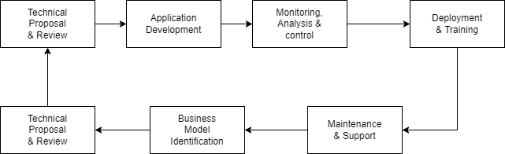

Fig. 3.1: The Process Workflow for the Development of Software Products

The diagram shows the process workflow for an enterprise developing software products. But Vaave, being a startup, did not employ such a strict workflow with its interns. The general process workflow for the development interns was as shown in the diagram below

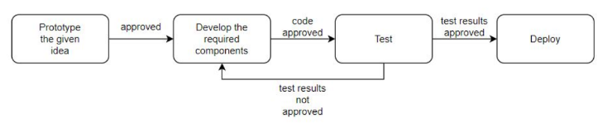

Fig. 3.2: The Process Workflow for the Development interns at Vaave

First, the development interns are given a task. They are then required to prototype the idea, which is generally an application page, on the web, mobile or desktop. If the prototype design is approved by the following teams:

* Design Team
* Sales Team
* Development Team,

then the prototypes must be materialized as components. This code is then to be approved by the development team for

* Quality
* Documentation
* Clarity
* Precision
* Conciseness and brevity

If the code is approved, then the code is tested by the testing team for working, speed and efficiency. If the test results are not satisfactory, the components must be developed again, with the flaws fixed. However, if the results are approved, then the components are deployed onto the website. Web application development includes application creation which is more than just a simple display of technology. It works on implementing the strategies for solving a problem, doing a process online, making the repeated task easier or automated, creating meaningful reports from data that would otherwise take hours or days, automated reminders and alerts to team and customers etc. The website is just a smaller part of conducting business online. These web applications make the work easier for businesses but are not visible to the public.

**3.2 Tools & Technologies Used**

**3.2.1 Technologies Used**

* PHP
* Laravel
* MVC
* HTML & CSS
* MySQL
* JavaScript
* Bootstrap

**PHP**

PHP is a general-purpose scripting language geared toward web development. It is a server scripting language and a powerful tool for making dynamic and interactive web pages. PHP is a widely-used, free, and efficient alternative to competitors such as Microsoft's ASP.

PHP is compatible with almost all servers used today (Apache, IIS, etc.) and supports a wide range of databases. It is also free to use.

**Advantages**

* PHP runs on various platforms (Windows, Linux, Unix, Mac OS X, etc.)
* PHP is compatible with almost all servers used today (Apache, IIS, etc.)
* PHP supports a wide range of databases

**Laravel**

Laravel is a free and open-source PHP web framework, created by Taylor Otwell and intended for the development of web applications following the model–view–controller architectural pattern and based on Symfony. Laravel is a web application framework with expressive, elegant syntax.

**Advantages**

* Laravel Development Means Faster Time-To-Market
* Better Authentication and Authorization Option
* Stay Away from Technical Vulnerabilities with Laravel Framework
* MVC Architecture of Laravel Framework

**MVC**

MVC (Model-View-Controller) is a pattern in software design commonly used to implement user interfaces, data, and controlling logic. It emphasizes the separation between the software's business logic and display. This "separation of concerns" provides for a better division of labour and improved maintenance. It is also done to separate internal representations of information from the ways information is presented to and accepted by the user. The Laravel web framework is largely based on the MVC architecture.

**Advantages**

* Accelerated Development Process
* Develop Multiple View Components for your Model
* Supports Asynchronous Method Invocation (AMI)
* Modifications do not Affect the Entire Model

**HTML and CSS**

HTML is a markup language for describing web documents (web pages). HTML stands for Hyper Text Markup Language. A markup language is a set of markup tags

CSS is a style sheet language that describes the presentation of an HTML (or XML) document. CSS describes how elements must be rendered on screen, on paper, or in other media.

**Advantages of HTML**

* Highly Flexible
* User-Friendly
* Easy to Maintain and update any site

**MySQL**

MySQL is the most popular Open source Relational SQL database management system. MySQL is one of the best RDBMS being used for developing web-based software applications. MySQL is a fast, easy-to-use RDBMS being used for many small and big businesses. MySQL is developed, marketed, and supported by MySQL AB, which is a Swedish company. MySQL is becoming so popular because of many good reasons:

* MySQL is released under an open-source license. So the programmer has nothing to pay to use it.
* MySQL is a very powerful program in its own right. It handles a large subset of the functionality of the most expensive and powerful database packages.
* MySQL uses a standard form of the well-known SQL data language.
* MySQL works on many operating systems and with many languages including PHP, PERL, C, C++, JAVA, etc.
* MySQL works very quickly and works well even with large data sets.

**JavaScript**

JavaScript (JS) is a lightweight, interpreted, or just-in-time compiled programming language with first-class functions. It was invented by Brendan Eich. JavaScript is versatile and beginner-friendly. It can also be used to create games, animated 2D and 3D graphics, comprehensive database-driven apps, and much more. JavaScript itself is relatively compact, yet very flexible. Developers have written a variety of tools on top of the core JavaScript language, unlocking a vast amount of functionality with minimum effort. These include

* Browser Application Programming Interfaces (APIs) built into web browsers, providing functionality such as dynamically creating HTML and setting CSS styles; collecting and manipulating a video stream from a user's webcam, or generating 3D graphics and audio samples.
* Third-party APIs that allow developers to incorporate functionality in sites from other content providers, such as Twitter or Facebook.
* Third-party frameworks and libraries that you can apply to HTML to accelerate the work of building sites and applications.

**Bootstrap Framework**

Bootstrap is the most popular HTML, CSS, and JavaScript framework for developing responsive, mobile-first websites. Bootstrap is completely free to download and use [and is also an](https://en.wikipedia.org/wiki/Free_and_open-source_software) [open-source](https://en.wikipedia.org/wiki/Free_and_open-source_software) collection of tools for creating [websites](https://en.wikipedia.org/wiki/Website) and [web applications.](https://en.wikipedia.org/wiki/Web_application) It contains [HTML](https://en.wikipedia.org/wiki/HTML)- and [CSS](https://en.wikipedia.org/wiki/CSS)-based design templates for [typography,](https://en.wikipedia.org/wiki/Typography) forms, buttons, navigation and other interface components, as well as optional [JavaScript](https://en.wikipedia.org/wiki/JavaScript) extensions. It aims to ease the [development](https://en.wikipedia.org/wiki/Web_development) of [dynamic](https://en.wikipedia.org/wiki/Dynamic_web_page) [websites](https://en.wikipedia.org/wiki/Dynamic_web_page) and [web](https://en.wikipedia.org/wiki/Web_application) applications.

Bootstrap is a front-end[framework,](https://en.wikipedia.org/wiki/Web_application_framework) that is, an [interface](https://en.wikipedia.org/wiki/Interface_(computer_science)) for the user, unlike the server-side code which resides on the "back end" or [server.](https://en.wikipedia.org/wiki/Server_(computing)) Bootstrap is compatible with the latest versions of [Google](https://en.wikipedia.org/wiki/Google_Chrome) [Chrome,](https://en.wikipedia.org/wiki/Google_Chrome) [Firefox,](https://en.wikipedia.org/wiki/Firefox) [Internet Explorer,](https://en.wikipedia.org/wiki/Internet_Explorer) [Opera,](https://en.wikipedia.org/wiki/Opera_(web_browser)) and [Safari](https://en.wikipedia.org/wiki/Safari_(web_browser)) browsers, although some of these browsers are not supported on all platforms.

**3.2.2 Tools Used**

* WAMP/XAMPP Server
* cPanel
* Visual Studio Code
* Web Browser

**WAMP/XAMPP Server**

Wamp/Xampp Server will install Apache, PHP5 and MySQL on system Windows system. Wamp/xampp Server comes with a service manager as a tray icon. It will allow programmers to easily manage the system server. Programmer can install all releases of Apache, MySQL and PHP as add-ons.

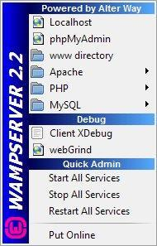

Fig 3.3: Wamp Manager 2.2

In order to create dynamic web applications with PHP, Apache and Php MyAdmin (MySQL database) WampServer allow users to set up a server locally on their Windows machine in the same conditions of development on the server and the programmer can upgrade components, develop, perform any web development task and carefully test everything offline first, which reduces the risks of creating problems on the live server.

**Features**

* Manage system Apache and MySQL services
* Switch online/offline (give access to everyone or only localhost)
* Install and switch Apache, MySQL and PHP releases

**cPanel**

cPanel is a web hosting control panel software developed by cPanel, LLC. It provides a graphical interface and automation tools designed to simplify the process of hosting a website for the website owner or the "end user". It enables administration through a standard web browser using a three-tier structure.

# Features

### Publish a website

* Create emails & calendars
* Backup, transfer & manage files
* Manage domains
* Launch databases

**Visual Studio Code**

Visual Studio Code, also commonly referred to as VS Code, is a source-code editor made by Microsoft. It is a code editor redefined and optimized for building and debugging modern web and cloud applications. Visual Studio Code is free and open source.

# Features

* Syntax Highlighting and Syntax Folding
* Support For Debugging
* Syntax Highlighting
* Intelligent Code Completion
* Snippets
* Code Refactoring

**Web Browser**

A web browser is a computer program that is used to access the web (to view webpages). A browser can also be used to download files and send and receive email or short messages across the internet.

Commonly-used web browsers, in order of market share:

* Google Chrome
* Microsoft Edge
* Firefox (Mozilla)
* Safari (Mac only)
* Opera

**CHAPTER 4**

**TASKS PERFORMED**

**4.1 Design of Webpages in the Vaave Website**

**INTRODUCTION**

The main website hosted by Vaave is the front end for all activities for the client. The client can browse through the services that Vaave provides, request demonstrations, etc.

The interns were tasked with developing entire web pages, or just specific components of the website.

There is also a webinar and seminar management application, called 13x, for which the interns were tasked to build interfaces to generate reports for the institutions to share with attendees, sign up pages for events, etc.

**System Actors (Users)**

* Alumni officers/heads of educational institutions
* Alumni officers/heads of corporate institutions
* Students
* Faculty
* Employees
* New visitors (potential clients)

**Admin Features**

* Create events
* Add event features
* Site Config
* View users
* Dashboard
* View Statistics

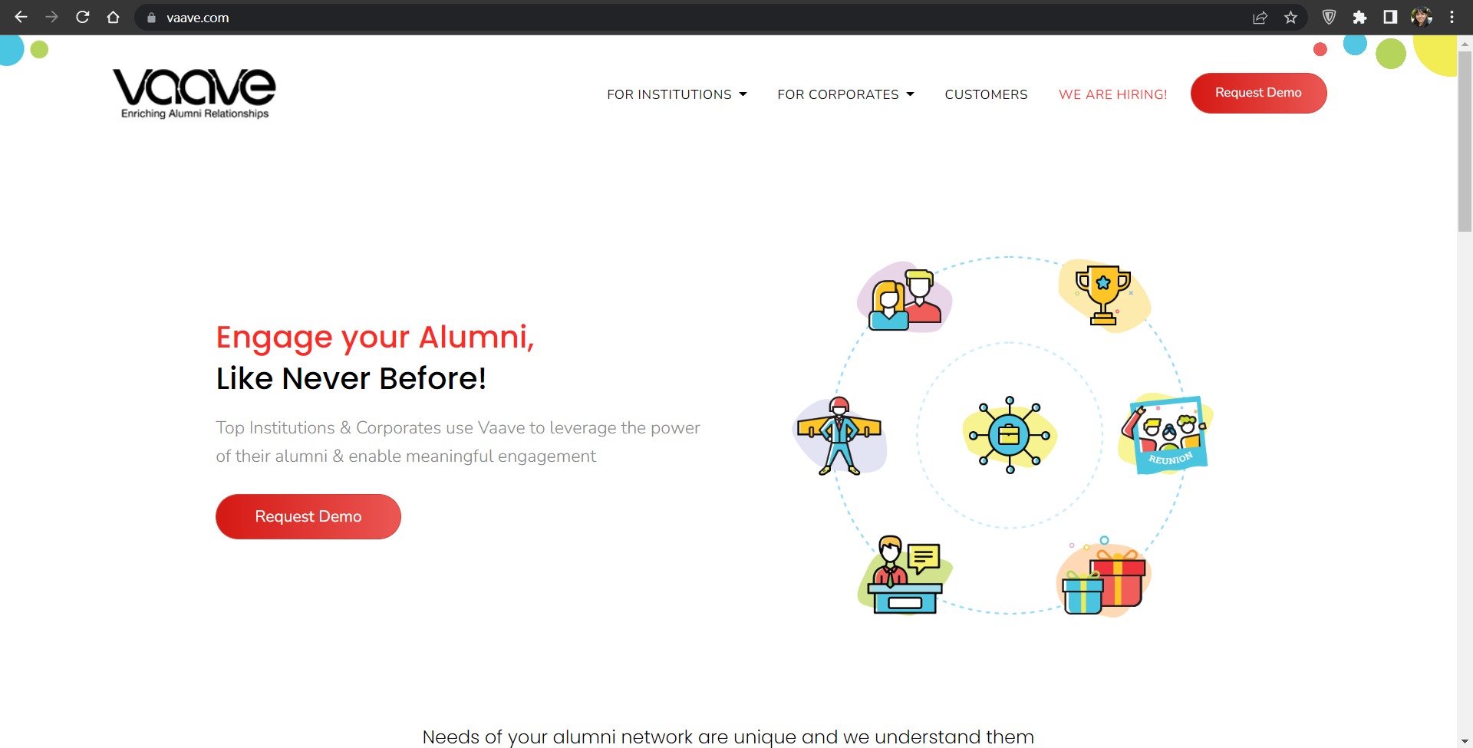

Fig 4.1: the front page of the Vaave website (<https://vaave.com>)

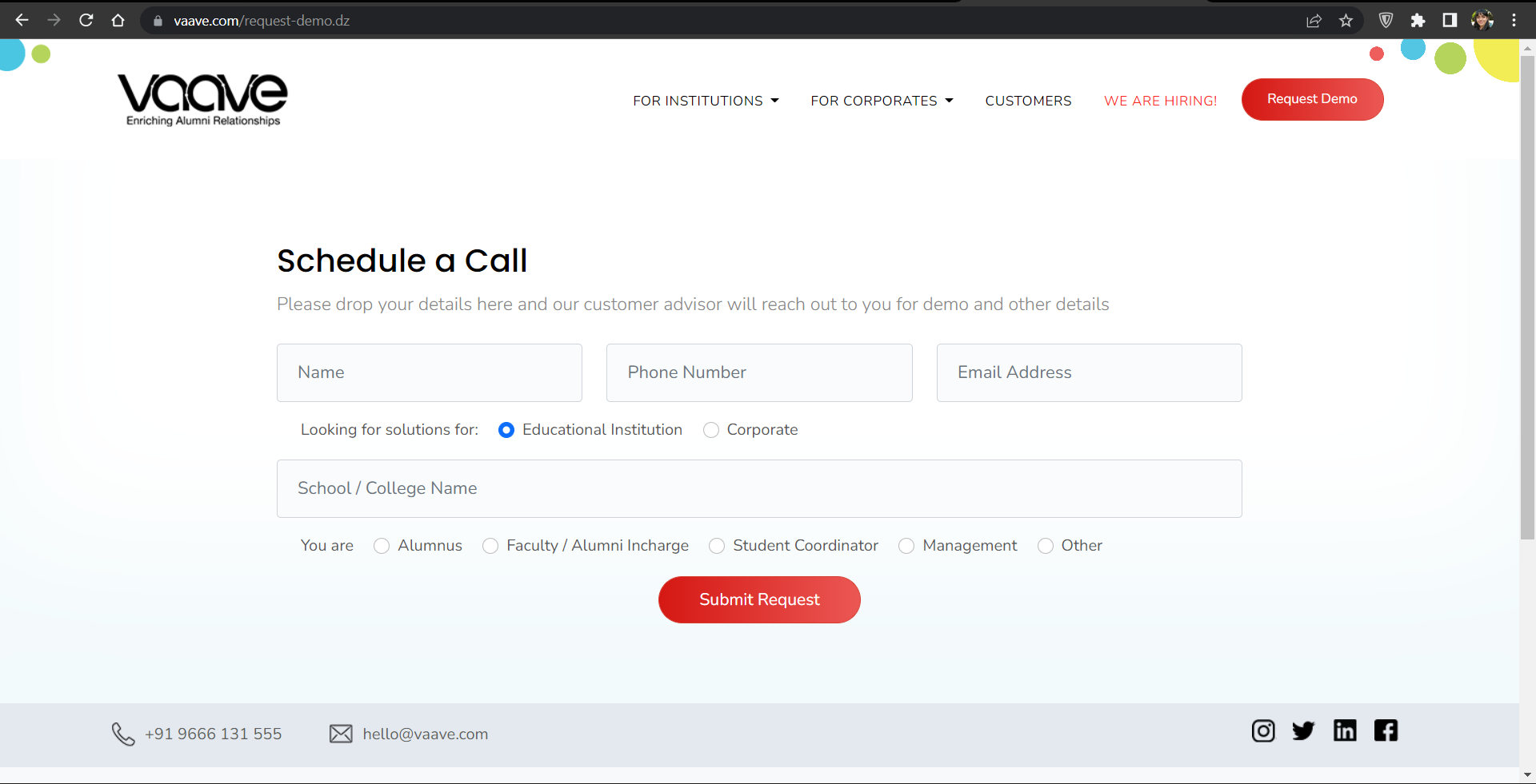

Fig 4.2: the page to request a demo of the Vaave suite of services (<https://www.vaave.com/request-demo.dz>)

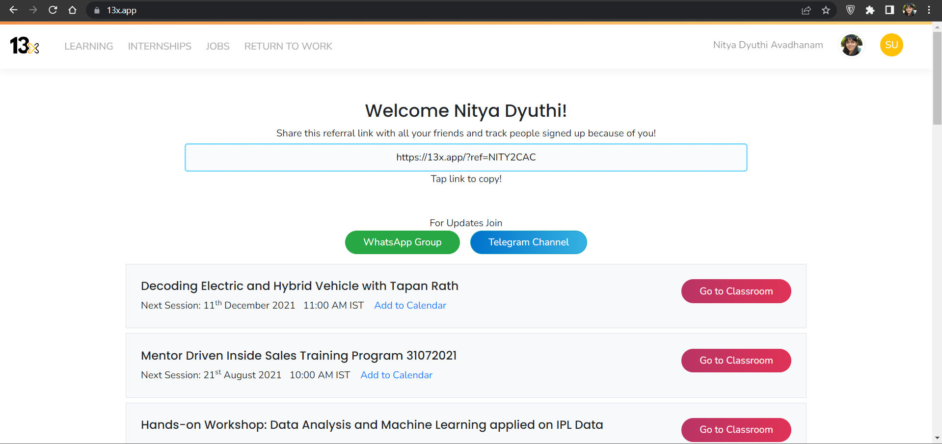Fig 4.3: The front page of the webinar and seminar app, 13x (<https://13x.app/>)

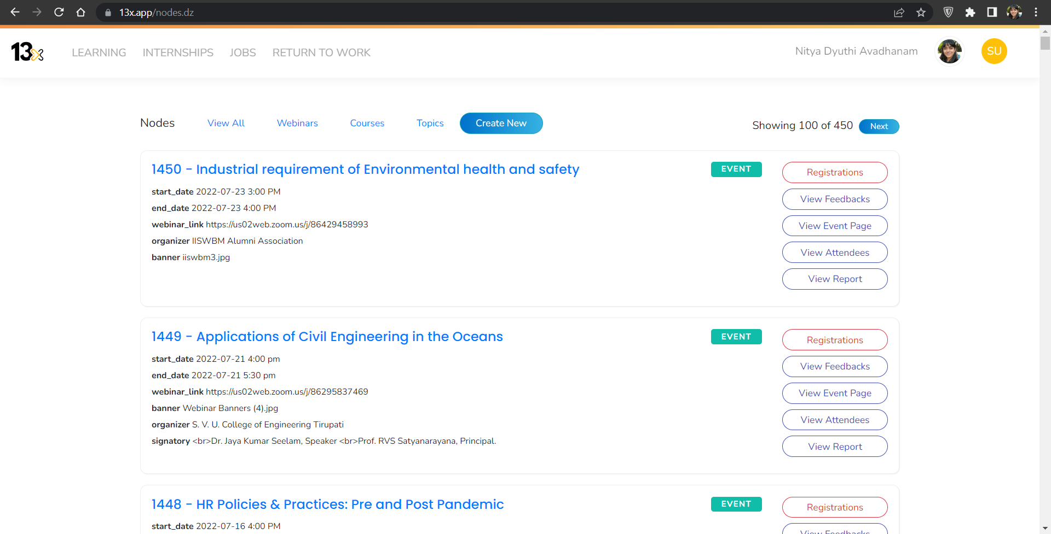Fig 4.4: The page to view the nodes of all the seminars/webinars that have been added to date, in the webinar and seminar app, 13x (<https://13x.app/>). This is a super user/ admin feature that is not available to ordinary users

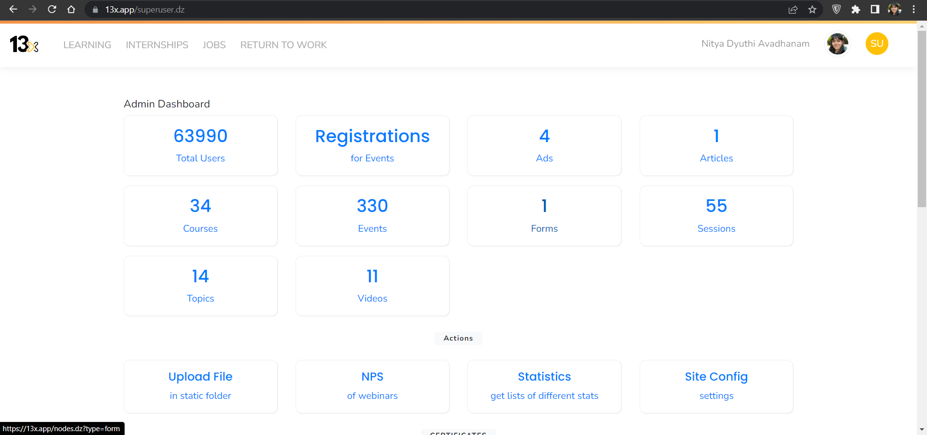

Fig 4.5: The page to view the statistics of all the seminars/webinars that have been added to date, in the webinar and seminar app, 13x (<https://13x.app/>).

**Software Requirements**

* Visual studio
* Language Used
  1. Front End (User Interface): HTML 5, JAVASCRIPT, CSS, PHP
  2. Server Language: PHP
  3. Back End: MySQL
  4. Web Browser
  5. Admin Controls: cPanel

**4.2 ACTIVITIES PERFORMED PER WEEK**

| **Week 1 Activities** |
| --- |
| * Domain Training - introduction to the system of work * Training on HTML, CSS, PHP and Laravel Assignments * Case Study Activities |

| **Week 2 Activities** |
| --- |
| * Team Formation * Training on SDLC, Bootstrap, MVC & CSS * Activities on Bootstrap & CSS |

| **Week 3 Activities** |
| --- |
| * Project Analysis & Design * Project Based Activities with team * Training on Bootstrap & CSS * Activities on JavaScript * Webpage development and testing standards introduction |

| **Week 4 Activities** |
| --- |
| * Project Based Activities with team * Activities on JavaScript * Assessment Test * Internship Project Work Presentation * Internship Report Preparation |

**CHAPTER 5**

**CONCLUSION**

During the Internship at Vaave, I learned to analyze and interpret the given problem with the right strategic approaches. Working as a team increased my productivity and coordination abilities and improved my ability to communicate better during the exchange of ideas, collaborating with others and keen observation skills.

The internship program has given me a great opportunity because it enables us to learn about the industry and various practices. It also teaches us about the various skills needed to work in an office with other employees. It offers something we can never learn inside a classroom setting. I have learned a lot of things that will help me build my career and also enhance my academic learning. I managed to put a lot of theories I learned in class into a practical application. Moreover, I have made valuable contacts in the industry and enriched my network greatly. Infidata has helped me to learn and develop my skills. The company has always encouraged me to learn the technologies and practices that interested me. I came to know about different tasks, learnt a variety of new technologies and many skills that are essential for building a career and provide a competitive advantage to me over others.

**CHAPTER 6**

**REFERENCES**

[1] <https://vaave.com>

[2] <https://13x.app/>

[3] <https://cpanel.net/>

[4] <https://laravel.com/>

[5] <https://www.wampserver.com/en/>

[6] <https://www.php.net/>

[7] <https://getbootstrap.com/>

[8] <https://developer.mozilla.org/en-US/docs/Web/CSS>

[9] <https://html.com/>

[10] Northstar Internal ERP